Superannuation and Tax

Glossary
Gross income – the total money you earn from your job (before tax and anything gets taken out).
Tax – money paid to the government for schools, hospitals, fire departments, police, roads, grants for skate parks, playgrounds, libraries, swimming pools etc.
Medicare levy – tax for people who don’t have private health insurance.
Superannuation – money put into a bank account, so you have money saved when you retire.

Superannuation
Your boss must put 9.5% of your gross pay into a superannuation account for you.
How much do the following people have to pay into their superannuation account?
Apple earns $500 a year; super =

Banana earns $19200 a year; super =

Carrot earns $50000 a year; super =

Durian earns $150,000 a year; super =

Eggplant earns $200,000 a year; super =

Feijoa earns $1500 a week; super (per year) =

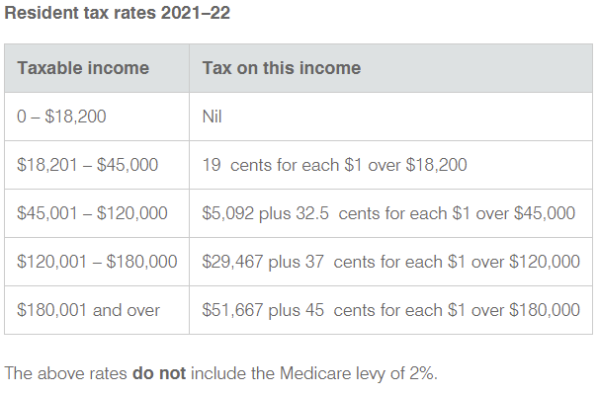
Tax

How much do the following people pay in tax?
Apple earns $500 a year; tax =

Banana earns $19200 a year; tax =

Carrot earns $50000 a year; tax =

Durian earns $150,000 a year; tax =

Eggplant earns $200,000 a year; tax =

Feijoa earns $1500 a week; tax =

Medicare levy
There are some different rules about this but simplified version; if you pay tax, and don’t have private health insurance, you pay an extra 2% of your gross income.
Assuming no one has private health insurance, how much do they pay in Medicare levy:
Apple earns $500 a year; Medicare levy =

Banana earns $19200 a year; Medicare levy =

Carrot earns $50000 a year; Medicare levy =

Durian earns $150,000 a year; Medicare levy =

Eggplant earns $200,000 a year; Medicare levy =

Feijoa earns $1500 a week; Medicare levy =

Net income
Net income is what ever is left over after everything’s been taken out.
Person | Gross Income  (per year) | Superannuation  (per year) | Tax  (per year) | Medicare  (per year) | Net income  (per year)
Apple | $500
Banana | $19200
Carrot | $50000
Durian | $150000
Eggplant | $200000
Feijoa

