Time Sheet and Net Income

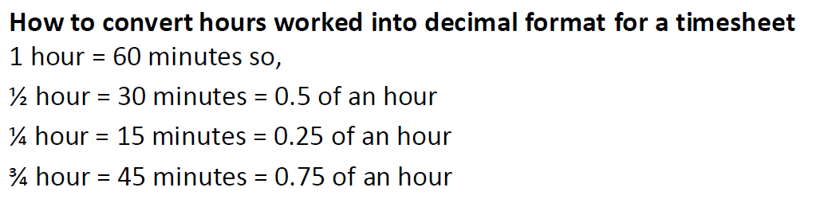

## Time worked



|  |  |  |  |  |  |
| --- | --- | --- | --- | --- | --- |
|  | Time Start | Time End | Time off | Total Hours | Signature |
| Monday |  |  |  |  |  |
| Tuesday |  |  |  |  |  |
| Wednesday |  |  |  |  |  |
| Thursday |  |  |  |  |  |
| Friday |  |  |  |  |  |
| Saturday |  |  |  |  |  |
| Sunday |  |  |  |  |  |



## Wages

|  |  |  |  |  |  |  |
| --- | --- | --- | --- | --- | --- | --- |
| Weekday |  | hrs @ $ |  | per hr | Total | $ |
| Saturday |  | hrs @ $ |  | per hr | Total | $ |
| Sunday |  | hrs @ $ |  | per hr | Total | $ |
|  |  |  |  |  |  |  |
| Total Gross Pay |  |  |  |  |  | $ |

## Gross Income

|  |  |
| --- | --- |
| Per week | $ |
| Per fortnight | $ |
| Per month | $ |
| Per year | $ |

## Net Income

Start with your annual (per year) gross income and subtract tax, Medicare levy and superannuation

Tax rates: <https://www.ato.gov.au/Rates/Individual-income-tax-rates/#Residents>

Medicare = 2% gross pay   
(**only** if you pay tax)

Superannuation = 9.5% of gross pay

|  |  |
| --- | --- |
| Gross income | $ |
| Tax | $ |
| Medicare Levy | $ |
| Superannuation | $ |
|  |  |
| Net income  (what’s left over) | $ |